

**MEDIA KIT 2020**

­­

113894 South Bangerter Parkway, Ste. 200 Draper, UTAH 84020kris@subVo.com

**WE DON’T MAKE THE SOUND.**

**WE MAKE THE SOUND PERFECT.**

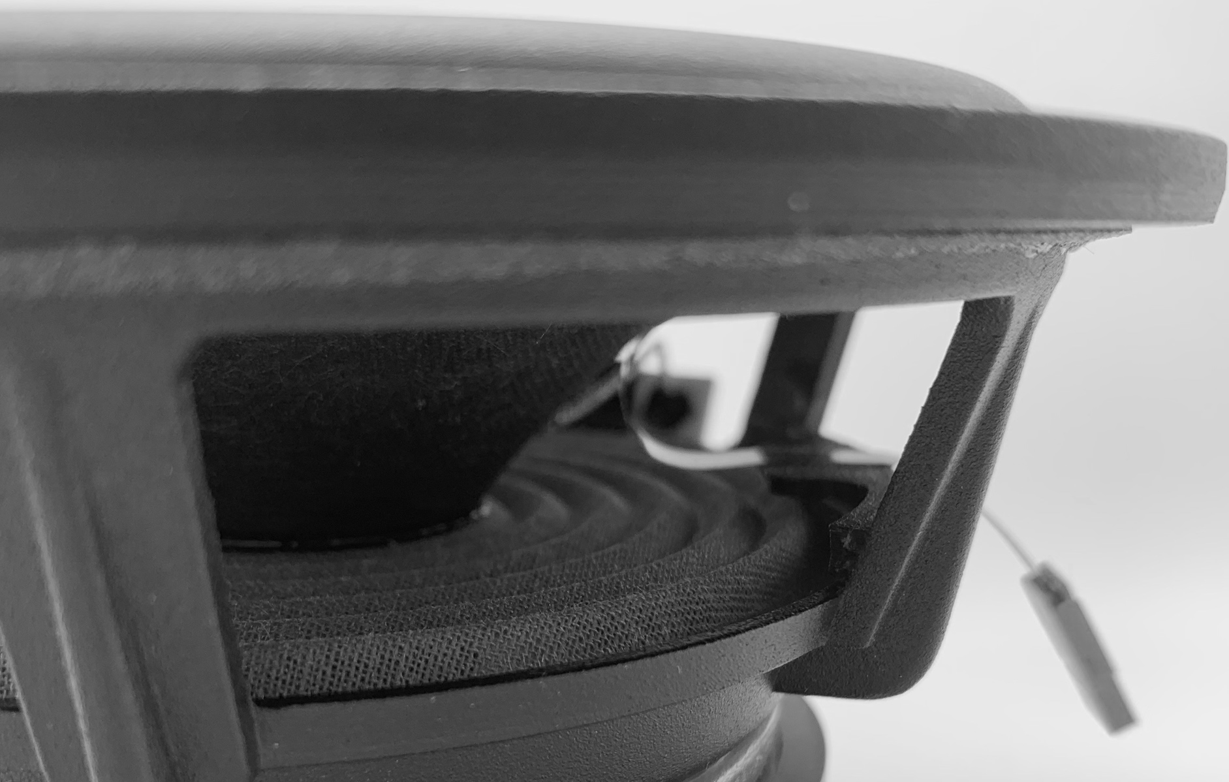

About the Company



MAKER OF klaraT

13894 South Bangerter Pkwy, Ste. 200,   
Draper, UTAH | info@subvo.com

MAKER OF klaraT

In February of 2019, Mechanical Engineer and self-professed audiophile Joe Harris happened upon entrepreneur John Kelley in a parking lot In Draper, Utah. What may sound like a shady first encounter (it wasn’t—it was the middle of the day after lunch with a mutual friend) turned into an innovative idea meeting opportunity. Joe had a concept. A theory. He knew if he could test his notion of how sound should well, *sound*, he would be able to introduce the world to something never heard before. John was intrigued (as an entrepreneur would be) and as the story goes, handed Joe cash from his pocket in order to purchase the necessary equipment needed to test the theory. When Joe’s idea proved to be a breakthrough in audio engineering, subVo was born and the diaphragm sensing and tracking technology now known as klaraT® came into existence.



Meet the Team



MAKER OF klaraT

Writer and CEO of Calvert Communications,   
**Executive Director of Marketing, Kris Calvert**has over twenty-five years in marketing and public relations. Working with fortune 500 companies in the areas of finance, integrated oil and gas, automotive, software, food service, architecture and engineering, she has extensive B2B and B2C experience. Kris is also a best-selling author with nineteen published titles.

Entrepreneur and CEO of company, IRR®,   
**Chief Business Officer, John Kelley**brings with him over 30 years of experience in leading teams in the software development, automotive, e-commerce, consulting, retail, sales and marketing industries. A visionary, John believes success as well as failure in business develops insight and understanding into the future realizations of new ideas   
and products.

13894 South Bangerter Pkwy, Ste. 200,   
Draper, UTAH | info@subvo.com

subVo’s resident whiz-kid, **Mechanical Designer, Camin Swartz** is charged with mapping the crazy ideas cooked up in subVo meetings.

**CEO, Joe Harris** is an Electrical Engineer with over twenty years of electronic design experience and ten years of sales and marketing experience. Joe has a true passion for audio and has spent most of his life perfecting Class-D amplifier architectures.

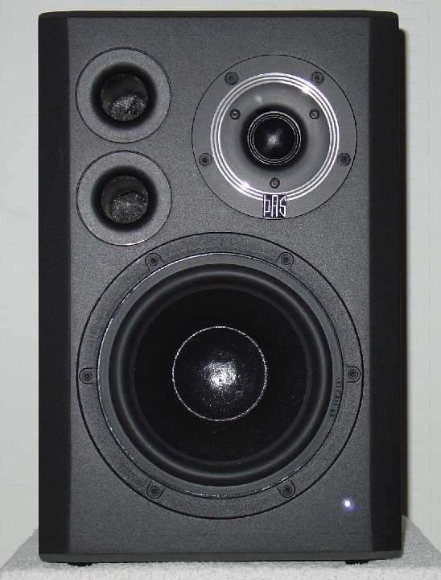

The accompanying software consists of a proprietary feedback control loop as well as speaker protection algorithms that enable speakers to operate at their limits without distortion or damage.

The transfer function of the diaphragm is mathematically linearized, dramatically reducing distortion.

The subVo sensor with a proprietary screen printed carbon ink, changes in resistance when bent. Added to the speaker diaphragm, or printed directly onto the diaphragm, the sensor maps the precise movements of the diaphragm.

The only sensor system capable of measuring the true position of a speaker’s diaphragm in real time through the entire audio spectrum, klaraT self-calibrates and produces unprecedented flat frequency response—even in tight enclosures like a smart phone—by quelling resonant frequencies and amplifying attenuated frequencies to maintain flat response across the audio spectrum.

How klaraT® works:

Physical constrains such as the mass of the diaphragm, the spring forces caused by the suspension, spider and the enclosure cause speaker design to become a juggling act within the laws   
of physics to produce the correct dynamics for perfect sound quality. Until now.

A Loudspeaker is the weakest link in any Audio System

MAKER OF klaraT

13894 South Bangerter Pkwy, Ste. 200,   
Draper, UTAH | info@subvo.com

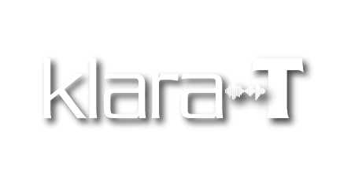



Tracking and adjusting for each and every sound, the klaraT® Technology and sensor tracks as well, if not more accurately than an expensive laser.

No space? No problem. With klaraT®, airspace can be reduced and speakers can be driven to their limits, exponentially improving upon sound quality and voice intelligibility.

• Limited Speaker Sizes Driven to their Limits

• Sound Perfection

• Cost Savings

For pennies on the dollar, each speaker, no matter how small, can be calibrated with every word or note. Not one time only on the factory floor.

Changing the way sound is heard

13894 South Bangerter Pkwy, Ste. 200,   
Draper, UTAH | info@subvo.com

MAKER OF klaraT

klaraT® is the name of the proprietary algorithm developed by subVo that runs in the DSP and controls the feedback loop and other features. klaraT® can eliminate costly calibration routines at production time by self-calibrating in the field. This compensates for any degradation of the loudspeaker over time and any change in the loudspeaker’s environment. klaraT® also manages the speaker protection algorithm which prevents the loudspeaker from damaging itself from over excursion.

[](https://www.macvoices.com/macvoices-20040-ces-subvo-improves-audio-performance-using-sensors-on-the-speaker/)[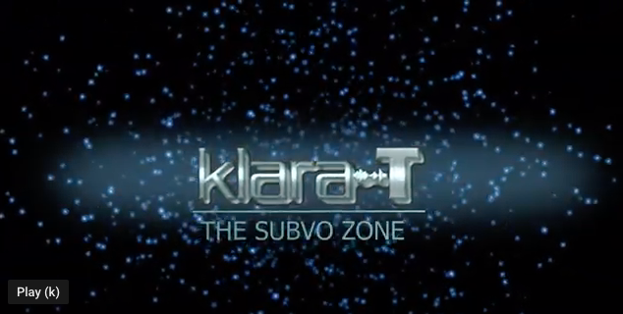](https://www.youtube.com/watch?v=QTAFLrUIids&t=1s)

MAKER OF klaraT

13894 South Bangerter Pkwy, Ste. 200,   
Draper, UTAH | info@subvo.com

**Speaker Calibration Hits CES 2020** 1/08/2020 GTech News

**subVo Improves Audio Performance Using Sensors on the Speaker** 1/19/2020 MacVoices at CES 2020

klaraT® and subVo in the News

info@subvo.com

Follow and connect with us:

13894 South Bangerter Parkway, Ste. 200

Draper, Utah, 84020

**All media enquiries contact:**

**Kris Calvert, Executive Director of Marketing**

[**kris@subvo.com**](mailto:kris@subvo.com) **| 859.312.8416**

Contact us

MAKER OF klaraT

13894 South Bangerter Pkwy, Ste. 200,   
Draper, UTAH | info@subvo.com

Address: